Genoa Colour Typology

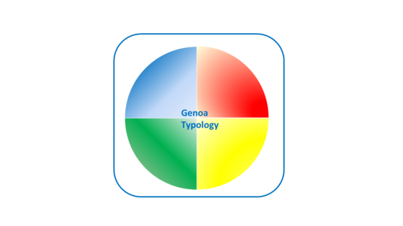

The Genoa Colour Typology exercise is great for staff team and Board away days.  In a colour typology session delegates identify their dominant personality traits as denoted by a colour.  They discover their strengths, displayed when they are having a good day, and the matters they need to be aware of for those 'off days!'

The model brings discovery of how best to interact with those with different colour traits.  The exercise is fun but is also an incredibly useful tool for building team awareness and for learning how best to interact with others.  The enlightenment improves personal development and team performance.

Genoa Colour Typology ©